Software Engineering Department  
Braude College

Capstone Project Phase B – 61998

**Lumbar Spine Degenerative Classification using an Optimized CNN**

**(24-2-R-1)**

**Supervisor:**

**Miri Weiss-Cohen**

**Submitters:**

**Almog Kadosh 315699439**

**Daniel Zada 318223278**

**Table Of Content**

General description 3

Describing the solution 4

**How the system works:** 4

References 6

# General description

In this project, we created an AI-based system to make it easier to analyze MRI images for patients with lumbar spine degenerative diseases. These diseases are often difficult to diagnose because analyzing MRI scans takes time and can vary between doctors. Our system was designed to help solve these problems by providing fast and accurate classifications.

The system uses the DenseNet deep learning model and transfer learning, which helps improve accuracy and reduces the amount of training needed. It can classify MRI scans into five specific conditions: Left Neural Foraminal Narrowing, Right Neural Foraminal Narrowing, Left Subarticular Stenosis, Right Subarticular Stenosis, and Spinal Canal Stenosis. These conditions are analyzed at different levels of the lumbar spine area (Fig.1) , from L1/L2 to L5/S1, giving detailed and specific results.

To make the system easy to use, we built a user-friendly interface. The backend was developed using Python, which handles tasks like processing images and making predictions with the AI model. The frontend was created with React, allowing users to upload MRI images and see the classification results clearly. This combination ensures that the system works efficiently and is simple for doctors to use.

The main goal of the system is to help doctors diagnose these spine conditions faster and more accurately. By automating the classification process, it reduces the chances of mistakes and allows doctors to focus on deciding the best treatment for their patients. This can also help patients by getting them the right treatment sooner and improving their outcomes.

The system is meant for medical professionals, such as radiologists, neurologists, and orthopedic surgeons, who work with MRI images. It provides them with a reliable tool to standardize and speed up their work while reducing errors.

In conclusion, this project combines AI and a well-designed interface to improve how lumbar spine conditions are diagnosed. By simplifying the process and providing consistent results, it helps both doctors and patients achieve better outcomes.

**Fig.1** human spinal skeleton showing cervical (yellow), thoracic (green), lumbar (pink) and saccro-coccygeal (blue) regions [1]

# Describing the solution

For this project, we developed an AI-based system that uses the DenseNet deep learning architecture combined with transfer learning to classify MRI images of the lumbar spine into specific degenerative conditions.

## **How the system works:**

1. **Input**: The system takes MRI images of the lumbar spine from the Kaggle dataset [2] as input. These images include different views like axial T2, sagittal T1, and sagittal T2 sequences (Fig. 2), which provide comprehensive anatomical details. MRI scans show the spine in different ways to help identify problems.Axial T2 gives a top-down view, showing the spinal canal and nerves.

Sagittal T1 gives a side view showing the bones and discs clearly. Sagittal T2 also shows a side view but highlights fluid and inflammation, which helps detect issues like swelling or disc problems. These views work together to give a full picture of the spine.

**Fig.2** Axial T2 (indicated by number 1), Sagittal T1 (indicated by number 2) and Sagittal T2 (indicated by number 3) MRI images of the lumbar spine.

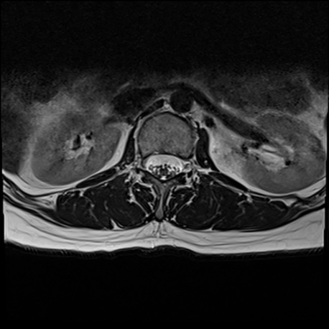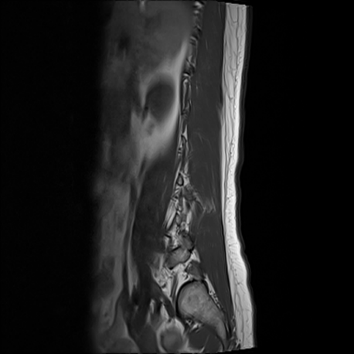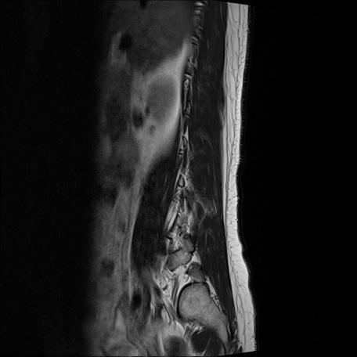

3

1

2

1. **Preprocessing:** The preprocessing pipeline prepares MRI images by resizing them to 512x512 pixels, normalizing pixel values for consistent scaling, and combining multiple image sequences into a single 30-channel tensor. During training, augmentations such as brightness adjustments, blurring, distortion, and cropping are applied (using the Albumentations library in python) to improve the model's ability to generalize and handle variability in the data. These steps ensure the input is clean, consistent, and diverse, enabling the DenseNet model to perform effectively.
2. **Model Architecture:**

**DenseNet-121:** In our project, we used DenseNet-121, a type of convolutional neural network (CNN) known for its smart and efficient design. Unlike other CNNs, DenseNet-121 connects every layer to all the layers before it. This means each layer can reuse features learned by previous layers, which makes the model more efficient and reduces unnecessary calculations. It also helps solve the problem of vanishing gradients, allowing the model to train effectively even with many layers. Overall, this design makes DenseNet-121 powerful and lightweight compared to other deep learning models.

To fit our project needs, we customized DenseNet-121. The original model processes 3-channel images (like RGB photos), but we modified it to handle 30 input channels to include MRI data from sagittal T1, sagittal T2, and axial T2 views. We also adjusted the model to predict 75 classes, representing five spinal conditions at five spinal levels (L1/L2 to L5/S1) and three levels of severity: Normal/Mild, Moderate, and Severe. This setup allowed DenseNet-121 to efficiently classify MRI images and provide detailed diagnostic results.

**Fig.3** 5-layer dense block with a growth rate of k = 4. Each layer takes all preceding feature-maps as input [3] ** change the image

# References

1. DO Neurological Surgery. *Spine & disc anatomy*. <https://www.doneurosurgery.com/spine--disc-anatomy.html>
2. Kaggle.com, *RSNA 2024 lumbar spine degenerative classification* [Data set]. <https://www.kaggle.com/competitions/rsna-2024-lumbar-spine-degenerative-classification/data>
3. Huang, G., Liu, Z., van der Maaten, L., & Weinberger, K. Q. (2018). Densely connected convolutional networks. Proceedings of the IEEE Conference on Computer Vision and Pattern Recognition (CVPR), 2017, 4700-4708. <https://doi.org/10.1109/CVPR.2017.243>